**EE 337 PROJECT-Bank Queue Simulator**

Simulation : Assume it circles back after 9 i.e 1,2,3,…9, 1,2,3…;

pinD=toggle on pinD

****************************************************************

T key -01

T key -02

T key -03

pinA -01

pinA -02

pinB -03

****************************************************************

T key -04 ,assigned to B as it was waiting

pinC -‘ ‘

T key -05, assigned to C as it was waiting

T key -06

T key -07

pinD -06

****************************************************************

T key -08

T key -09

T key -01

T key -02

pinD -08

pinA -09

pinB -01

pinB -02

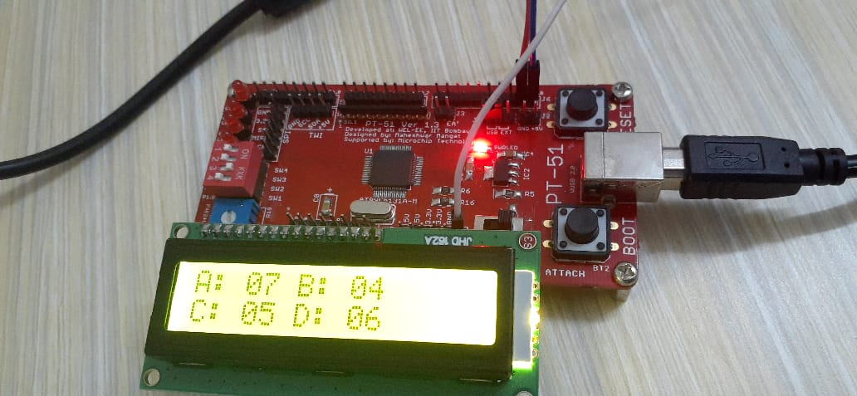

Token 4 being issued